Course Projects for COMP 680E
1-page Proposal: March 20, 2007
Project Presentations: Final 2 weeks of semester
Final Project Report: Week of May 21, 2007

Objective:
The objectives of the project are:
- To get very familiar with a specific topic related to switches and routers
- To survey state-of-the-art research efforts in the area
- To survey state-of-the-art commercial products in the area
- Give your input and opinion about both the research as well as the commercial side of the area
- To document your surveys (as well as your own input) into a small written report
- To present your findings to the whole class in a 30-minute presentation

Logistics:
- A number of potential projects are listed below (you can choose your own project).
- Form a group of 2.
- The projects are chosen on a first-come-first-served basis and through consultation.
- A 1-page proposal listing some key references are to be submitted by March 20.
- A 30-minute presentation is to be give in the last two weeks of the semester
- A final report is to be handed in during the final week of classes

Potential projects

General Projects

Project #1 IP Core Routers

IP core routers are high-performance routers that form some of the key building blocks of the Internet. This project intends to survey all the architectures that have been proposed for these types of switches in both academia and industry (Input queued, output queued, shared memory, massively parallel, etc.). In addition, the project should cover all the major building blocks of the architectures (e.g., network processors, fabric, schedulers, traffic managers, etc.). Then you should discuss the capacity, scalability, and functionalities (types of interfaces, reliability, etc.) of these core routers.

Project #2 Optical Switches (packet and Circuit-based)

DWDM is projected to be the ultimate solution by most of the optical service providers to quickly respond to an increasing need for bandwidth, particularly in the long-haul core network. This wavelength-based infrastructure creates the foundation for the new generation optical networks and optical switches help to manage this new transmission capacity. To guarantee a lower cost, and secure efficiency with new revenue-generating services, there are two choices of optical switches, the Electronic-base switch O-E-O and the all-optical, photonic-based switch O-O-O.

Basically, an optical switch maps wavelengths from an input port to the appropriate output based on their destination. An O-E-O switch is an optical switch that route information not based on optical technology, but instead based on using electrical components. The input/output modules are optical, but receivers turn the photons back into electrons form their journey over an electronic back-plane. At the output module, the electrons are converted back into photons to follow their path through a fiber transmission link. Here is an example of an O-E-O switch architecture:

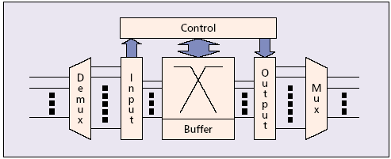

O-E-O model is a very flexible architecture, which is the benefit of performing regeneration of the signals and allows SONET-level performance monitoring of the stream. However, this architecture is blamed to be costly because of the higher price of the Optical-to-electrical (OE) conversions. In addition, it may encounter the problem of not capable to keep pace with the growth in capacity of optics in the future.

Recently, micro-electro-mechanical systems (MEMS) and other optical switching technologies have received much attention due to their ability to eliminate O/E/O conversions, and thereby the electronic bottleneck at switching nodes. However, in order to build an all-optical network where data is kept in the optical domain at all intermediate nodes, novel protocols (software) running on top of optical switches/routers also need to be designed. One of the challenging issues is how to support fast resource provisioning, asynchronous transmission (of variable size packets, e.g., IP packets), and a high degree of statistical resource sharing for efficient handling of bursty traffic, all without requiring buffers at the WDM layer since there is no optical form of random access memory RAM) available today.

In summary, this project is to cover state-of-the-art advances in research and commercial products related to optical packet switches as well as optical circuit switches.

Project #3 Optical Burst Switching

There are three switching techniques for optical networks: wavelength routing, optical packet/cell switching, and Optical Burst Switching (OBS). OBS is a novel approach of aggregating multiple IP packets into a burst that is then transmitted without the need for any type of buffering at intermediate nodes. It is one method of transporting IP directly over a bufferless optical WDM network.

OBS combines the best of circuit and packet switching while avoiding their shortcomings. It is based on one-way reservation without waiting for an acknowledgment, resulting in much lower end-to-end latency than in circuit switching. When applied to the next-generation optical Internet, the control packet will be processed at each and every intermediate IP entity to establish an all-optical path (by configuring the WDM switches), but the corresponding burst (e.g., several IP packets) will go through only the preconfigured WDM switches at the intermediate nodes along that path.

An OBS protocol called Just-Enough-Time (JET) works as shown in the following graph:

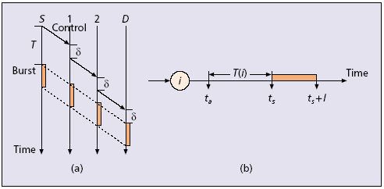

A source sends out a control packet, which is followed by a burst after a “base’’ offset time, T ≥ SHh =1d(h), where d(h) is the (expected) control delay (e.g., the processing time incurred by the control packet) at hop 1 £ h £ H (Fig. (a), where H = 3 and d(h) = d). Because the burst is buffered at the source (in the electronic domain), no fiber delay lines (FDLs) are necessary at each intermediate node to delay the burst while the control packet is being processed. In addition, JET-based OBS can achieve efficient bandwidth utilization by using delayed reservation (DR) (Fig. (b)), whereby the bandwidth on the output link at node i (e.g., i = 1, 2) is reserved from the burst arrival time, denoted ts, instead of from the time at which the processing of the control packet finishes, denoted by ta (since the offset time remaining after i hops is T(i) = T – Sih =1d(h), we have ts = ta + T(i)). In addition, the bandwidth will be reserved until the burst departure time ts + l, where l is the burst length. If the requested bandwidth is not available, the burst is said to be blocked and will be dropped if it cannot be buffered. A dropped burst may then be retransmitted later. Note that JET-based OBS can also take advantage of any FDLs available at an intermediate node in resolving contention among multiple bursts by using the FDLs to delay a blocked burst until bandwidth becomes available, thus achieving better performance (e.g., lower burst dropping probability) than packet/cell switching where FDLs are not used for the purpose of resolving contention (at least not 100 percent of them).

While there are no commercial products that I am aware of based on OBS, nevertheless numerous research is currently being undertaken using this paradigm. This projects is to survey all the research efforts related to OBS.

Specific Projects

Project #4 Network Processors
The primary role of routers is to forward packets toward their final destinations. To this purpose, a network processor must analyze the packet header to find the address of the next-hop router as well as the egress port through which the packet should be sent. This forwarding information is stored in a forwarding table that the router computes based on the information gathered by routing protocols. The operation is called address lookup.

As we know, the 32-bit IP address consists of network prefix and host address. IP routers forwarded packets based only on the network part, until packets reached the destination network. As a result, a forwarding table only needed to store a single entry to forward packets to all the hosts attached to the same network. An example of forwarding table is shown below.
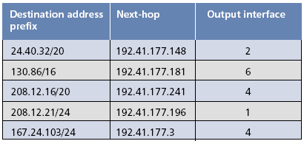

The use of classless inter-domain routing (CIDR) allows arbitrary aggregation of network addresses and reduces routing table entries. This complicates the lookup process, requiring a lookup engine to search variable-length address prefixes.
This project is to survey state-of-the-art research and commercial products for table lookup network processors. This includes the algorithms adopted, the technology used, the functionality of the processors, their capacity, and scalability.

Project #5 Packet Classifiers

Internet routers classify packets to implement a number of advanced Internet services: routing, rate limiting, and access control in firewalls, virtual bandwidth allocation, policy-based routing, service differentiation, load balancing, traffic shaping, and traffic billing. These services require the router to classify incoming packets into different flows and then to perform appropriate actions depending on this classification.

Flows are specified by rules applied to incoming packets. We call a collection of rules a classifier. Each rule specifies a flow that a packet may belong to based on some criteria applied to the packet header. When a packet arrives at a router, the classifier must find a rule in its rule database that matches the packet headers. Here is an example of four-dimension classifier;

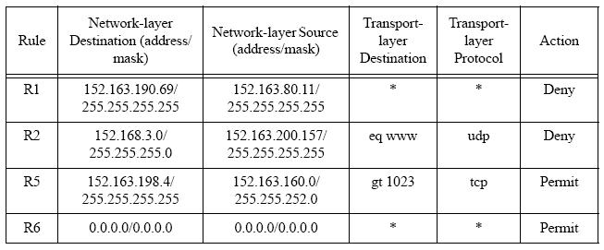

Performance metrics for classification algorithms includes: 1) Search speed; 2) Low storage requirements; 3) Ability to handle large real-life classifiers; 4) Fast updates; 5) Scalability in the number of header fields used for classification; and 6) Flexibility in specification.

This project is to survey of the research efforts and commercial products related to packet classifiers.

Project #6 VOQ Crossbar Schedulers
Since in one time slot, each input can send at most one packet, and each output can receive at most one packet, scheduling algorithms are necessary for crossbar switches to find a proper one-to-one match between inputs and outputs in order to configure the crossbar. A variety of scheduling algorithms are proposed for the VOQ architecture.

Some popular and effective schemes are:

1) Maximum Weight Matching (MWM) scheduling algorithms
In MWM algorithms, a weight is attached with each request from inputs to outputs. The weight could be the number of cells in the VOQ, the waiting time of HOL cell in the VOQ, etc. The algorithm picks a match such that the weight of the matching is maximized. MWM scheduling algorithms achieve 100% throughput under any admissible traffic. However, the good performance in stability is at the expense of high computation complexity.

2) Maximum/Maximal Size Matching (MSM) scheduling algorithms
This type of algorithm picks a match that maximizes the number of input/output connections. They are favored due to their simplicity to be implemented in hardware with today’s technologies. They provide 100% throughput under uniform traffic and fairly good delay performance as well. However, MSM are not stable under non-uniform traffic. Most of the MSM algorithms take an iterative Request-Grant-Accept (RGA) procedure. The following graph shows the RGA in a 4x4 switch.

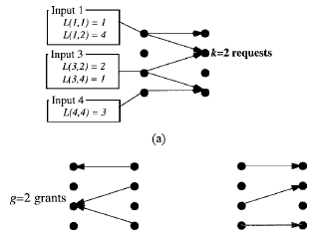

3) Randomized Scheduling Algorithms
Recently, randomized algorithms are proposed to overcome the complexity of MWM algorithms and to achieve stability under any admissible traffic as well. They are proved to be stable under all admissible traffic too. But with the help of memory, these algorithms are much simpler than traditional MWM algorithms.
This project is to survey all the research and commercial schedulers/arbiters that been proposed for VoQ crossbar-based switches.

Project #7 VOQ/CIOQ QoS Guarantees
In reality, the Internet needs to guarantee some level of qualities-of-service (QoS). QoS can be provided using weighted fair queuing (WFQ)-based packet scheduling. All of the work on WFQ-based scheduling algorithms requires that switches/routers use output-queuing (OQ) or centralized shared memory. However, such switch architectures maybe costly with high speed or large port number.

A typical approach is to emulate the OQ using VOQ/CIOQ architecture. Here is architecture of CIOQ switch. A CIOQ switch is said to behave identically to an OQ switch if, under identical inputs, the departure time/sequence of every cell from both switches is identical.
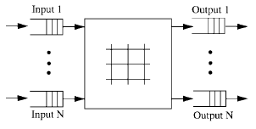
It has been firstly formulated by Prabhakar and Mckeown in that a CIOQ switch with a speedup of 4 can behave identically to a FIFO-OQ switch. Their proof is based on the scheduling algorithm called Most Urgent Cell First (MUCFA). The urgency value of a cell used in the MUCFA is defined as the distance it clones it from the head of the output buffer in the shadow switch. The cells in any output buffer of the CIOQ switch are arranged in increasing order of urgencies, with the most urgent cell at the head. Once a cell is forwarded to its output in the CIOQ switch, its position is determined by its urgency. MUCFA is extended to achieve the exact emulation by a speedup of only 2 by a new algorithm called Joined Preferred Matching (JPM) algorithm. Similarly, the Critical Cell First (CCF) has been proposed to emulate OQ switch with speedup 2 and with different output scheduling disciplines.
This project is to survey all the research and commercial efforts used in emulating OQ switches using IQ switches.

Project #8 Active Queue Management

The TCP transport protocol has the ability of detecting congestions when a packet has been dropped, and adjusts its transmission rate accordingly. However, a lot of TCP implementations do not include the congestion avoidance mechanism. Furthermore, UDP flows (e.g.; voice, video) may keep sending packets even when they receive a congestion indication. Consequently, the bandwidth is more easily used up by then than other TCP compatible flows. As a result, an effective detection of congestion and the ability of achieving fair share among flows should be implemented in the routers. Active queue management (AQM) algorithms help end hosts make decisions about transmission rates by providing congestion information based on characteristics of a router’s queue. The advantages of such feedback seem obvious, and the IETF recommends the use of AQM to reduce loss rate, to support low-delay interactive services, and to avoid TCP lock-out behavior.

The most well-known AQM algorithm is the Random Early Detection (RED) gateway. A router implementing RED maintains a single FIFO to be shared by all the flows, and drops an arriving packet at random during periods of congestion. The drop probability increases with the level of congestion. By keeping the average queue-size small, RED reduces the delays experienced by most flows. The problem of RED is it has no ability to distinguish unresponsive flows and to achieve fair queuing. An improvement is CHOKe which differentially penalizes misbehaving flows by dropping more of their packets. By doing this, CHOKe aims to approximate max-min fairness for the flows that pass through a congested router. The procedure of CHOKe is shown in the following graph:
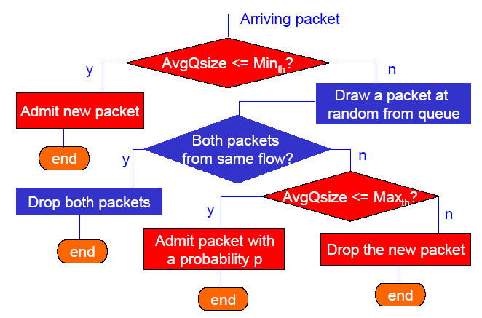
This project is to survey most of the research and commercial efforts related to AQM.

Project #9 Gigabit Ethernet
In today's networks, Ethernet accounts for approximately 80% of all LAN connections, with numbers steadily increasing as Gigabit Ethernet delivers what customers need. Gigabit Ethernet is the latest speed extension of the ubiquitous Ethernet technology. It is currently in the draft stage of IEEE standardization and is known as IEEE P802.3z draft standard.
Ethernet is successful for several reasons. The technology is simple and uncomplicated, and this translates into high reliability and low cost of maintenance. Ethernet continues to evolve to meet the needs of its customers, as evidenced by the dash to standardize Gigabit Ethernet so quickly. In addition, Gigabit Ethernet offers higher performance, lower maintenance costs, lower cost of entry and increased scalability when compared to other high-speed technologies.
One leap in the drive to standardize Gigabit Ethernet came through adapting existing technology. When creating a new high-speed networking system, the largest obstacle to overcome is developing a physical layer which can reliably deliver data at increased speeds. To circumvent this problem and advance the entire process more quickly, the HSSG (High Speed Study Group) proposed a crossover of technologies. The well-characterized and well-understood IEEE 802.3 MAC was layered on top of the already developed and tested physical layer of the ANSI standard Fibre-Channel. In this manner, a high-speed system could be engineered without the risk of developing a completely new and untried physical layer.
This project is to survey the most recent technologies and applications of gigabit Ethernet.

Project #10 Storage Area Networks
A SAN, or storage area network, is a dedicated network that is separate from LANs and WANs. It generally serves to interconnect the storage-related resources that are connected to one or more servers. It is often characterized by its high interconnection data rates (Gigabits/sec) between member storage peripherals and by its highly scalable architecture. Though typically spoken of in terms of hardware, SANs very often include specialized software for their management, monitoring and configuration.
SANs can provide many benefits. Centralizing data storage operations and their management is certainly one of the chief reasons that SANs are being specified and deployed today. Administrating all of the storage resources in high-growth and mission-critical environments can be daunting and very expensive. SANs can dramatically reduce the management costs and complexity of these environments while providing significant technical advantages.
This project is to survey both the hardware and software configurations in SANs and identify their applications as well.

Project #11 QoS Algorithms
The inclusion of QoS into the Internet has been proposed for a long time. This includes standards such as RSVP and DiffServ. In addition, most commercial switches and routers have QoS capabilities even though they are seldom used.
This project is to survey all the frameworks and algorithms proposed for QoS. Then, it should compare their strengths and weaknesses. In addition, it should give some guidance into the commercial chips and products that are already available and pin-point the difficulty of designing these products.

Project #12 Networking Security
One of the key challenges of this information age is network and data security. The aim of this project is to survey and assess the security mechanisms that are being proposed and adopted for both wired as well as wireless networks.

Project #13 Peer to peer communications
P2P is an alternative communication model besides the well-established service access models, such as the client-server model and the push model. The idea in the P2P model is twofold: (1) plain sharing of information among users, and (2) work in tandem with the client-server model for performance reasons. So far, P2P networks have relied on the fixed Internet infrastructure. New challenges in designing P2P network systems will include communication protocols to support P2P communications in a heterogeneous network including the fixed Internet, wireless LANs, and the 3G/4G systems. The project will survey current research on the P2P systems and pioneering work of adding mobility to the P2P services.

